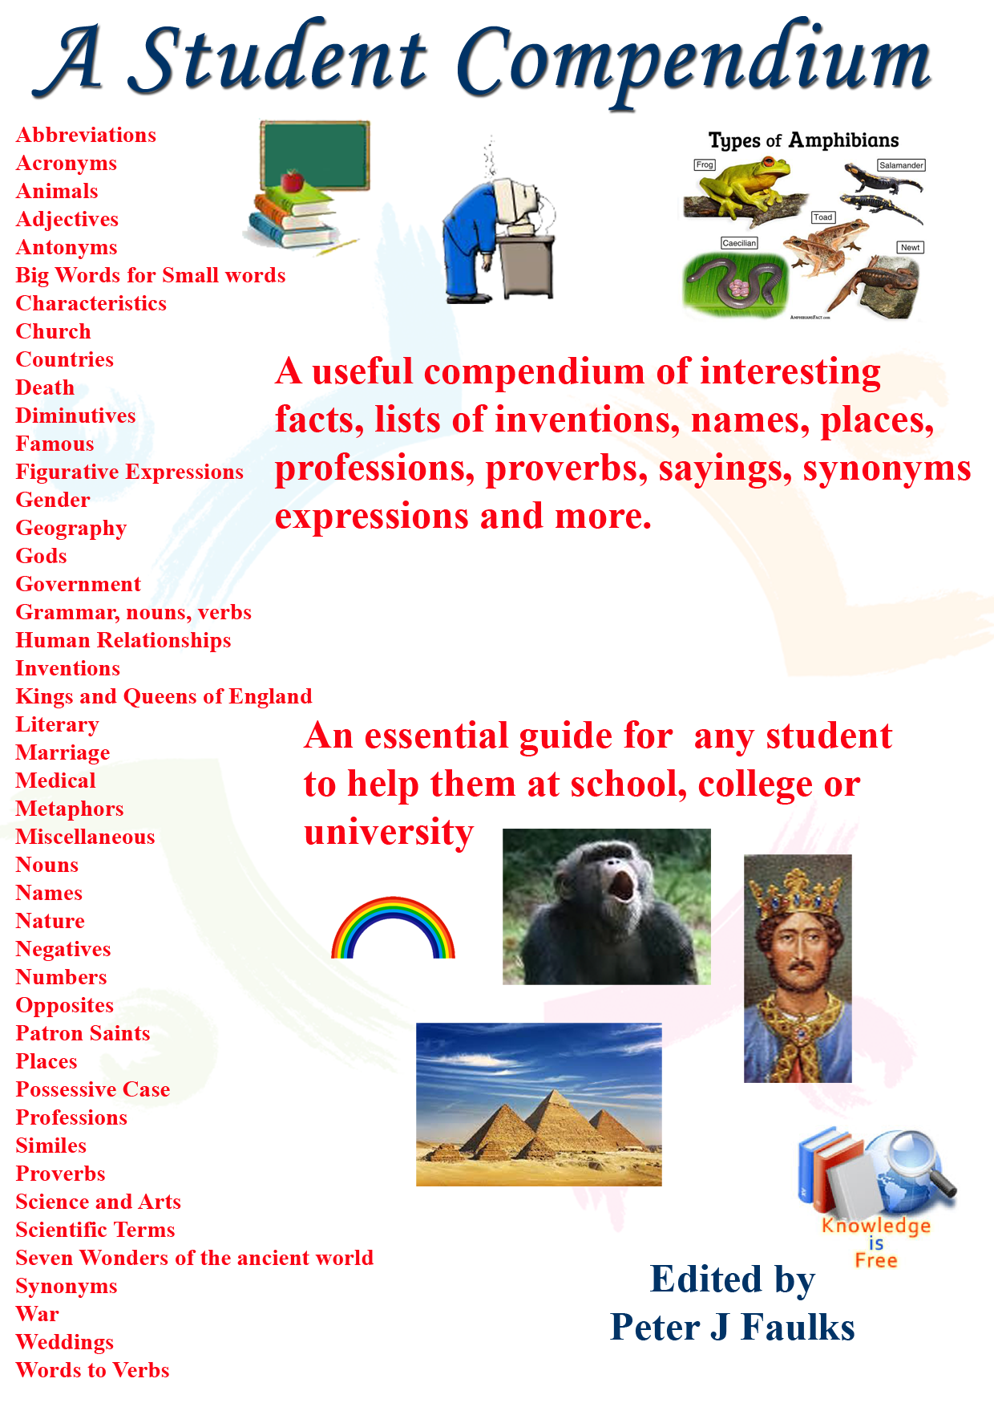
A brief slightly fictionalized look at
Digital Technologies (The facts have been altered to make it interesting)

During Y7 Digital Technologies we will look at Binary Digital, Networks, Hackers, computer viruses and scammers, computers, hardware and how they work and look at the internet and social networking.
To help get a feel for the course here is an extract from my web site
http://peterfaulks.net/Teaching/Student_Compendium.htm

http://www.peterfaulks.net/Teaching/Student_Compendium/SC054_communication.htm

By Peter J Faulks

We start this Year 7 Digital Technologies course looking at how people communicated and how this developed into digital technology, going back in time. Early humans who needed to communicate when hunting used hand signals, this was fine if they could see each other so eventually they developed smoke signals and all sorts of forms of communicating, leading to flags, mirrors and any way that they could get in touch with each other, this usually occurred using relays of signals from village to village or runners or horses and even pigeons! So there was always a constant effort being made to communicate. We learnt to write and read so we could send written dispatches. Printing presses were invented so we now had mass produced news sheets, magazines and books and we were all getting smarter as long as we learnt to read and write.

Sometimes the messages got miss-translated and we see armies going the wrong way or like the Charge of the Light Brigade charging up the wrong valley.

So we only had written communication for many centuries until the mid 18th Century, in 1752. Benjamin Franklin discovered electricity with his famous kite-flying experiments, he discovered electrical pulses from a kite he flew in a lightning storm, and then in 1833 Michael Faraday, was the first one to realize that an electric current could be produced by passing a magnet through a copper wire.

This led us to a whole new age of communication, in 1879 Thomas Edison spent time working on an electric current he called Direct Current (DC = Batteries etc.), his partnership with the great Nikola Tesla caused a rift and they split because in May of 1888 After receiving a patent on the “electric transmission of power”, Tesla subsequently demonstrated alternating current (AC) electricity and in 1893, Tesla discovered the rotating magnetic field and created the alternating current electrical system AC voltage, this obviously conflicted with what Edison wanted to sell to the world and they split up, eventually Tesla proved that AC could be transmitted over longer distances was more reliable so he won (although he eventually ended up in poverty after his struggles to sell his idea), AC voltage is now used world wide, today in Britain and Australia we use 240 volts, in the USA and other countries they use 110 volts system, but AC electricity can be deadly, but Edison’s direct current just would not work over long distances and we all know how long batteries last. Edison focused on inventing many other things like a practical light bulb, one that would last a long time before burning out. He also developed the gramophone (1891) using plastic tubes and horn speakers.

So the whole world was transformed with electricity and using light bulbs created by Edison we moved from fire, whale oil, candles and gas to the electric bulb (using AC voltages). The world of digital technology was about begin.

So how does this affect digital technology, during the wars we realized messages and smoke signals just could not cut it so we needed to send messages more accurately; then Samuel Morse and his assistant Alfred Vail came up with a device that could send a signal over a wire in short distances if you wound up a copper wire fast around a magnet for a short time. He could reach 2km or by linking wires to poles, up to about 200 miles (321 km) but only if wires were joined by poles and relays (another wind up generator) and with poles a short distance apart and he and Alf developed Morse Code using dots and dashes in short sequence sets usually in threes, (down on, up off) and we all now know that dot dot dot, (press down quickly three times) dash dash dash, (press and hold three times) and dot dot dot means S.O.S, thanks to the Titanic disaster in 1912. Consequently we saw thousand’s of wires stretched across countries carrying wire messages in dots and dashes. Which worked well until someone cut the wires!

Then along came Guglielmo Marconi from Italy who started playing with wires using electromagnetic waves to send signals, building much of his own equipment in the attic of his home at the Villa Griffone in Pontecchio along with his butler (no one remembers the butler).

At that time, the telegraph wire was the quickest way to get messages from here to there, using the Morse code tapping out signals on a morse code key. Guglielmo designed a transmitter to send and a receive radio waves and in 1895, he discovered he could send messages through the air without wires. He called this wireless and although it could only travel about 2 miles (3.2 km) it could travel over water or hills without wires. He had to go to England for sponsorship and after some success went on to America where after he improved his antennas and grounded his transmission poles he improved the distance so that sound waves could travel through the air further. He sent a signal over water from a ship about 60 odd kms away to a land station receiver, and from that moment on we had wireless.

We come back to the Titanic disaster where signals were sent out by Marconi employed radio technicians about 20 to 40 kms out from the ship (depending on the weather) using transmitters and receivers, reaching other boats that came to rescue passengers from the sinking ship, saving many lives, "Those who have been saved, have been saved through one man, Mr. Marconi ... and his marvelous invention. Of course after the disaster it was agreed to use SOS and the emergency signal. But wireless was here to stay.

People started buying wireless radios, companies stared broadcasting sound using various wave lengths like 720 am (amplitude modulation, which refers to the means of encoding the audio signal on the carrier frequency. In many countries, AM radio stations are known as "mediumwave" stations). Later using Frequency Modulation 9.6 fm which could travel further in better sound quality, with music and spoken voice we had a world of communication.

We even saw the invention of the camera and of movie making.

Streets and cities had lights and we all had a great time listening to music. Then we started the 1900’s with moving pictures and silent movies about 1930’s moved on to talkies and talkies with colour (about 1950’s) and we all went to the cinema to watch marvelous movies in the early 20th century walking under 250 volt street lights, or in America 110 volt lamps.

But along came some wars 1914 and 1939 and we needed a new way of communicating. Short wave radio was used but had to be tuned into the correct frequency, we sent a whole lot of paratroopers into France during world war II with the radio sets with the wrong frequency and most ended up not able to communicate with England so they enjoyed time in a German prisoner of war camps till the war ended.

Anyway during the second world war we needed better communication and although Charlie Babbage around 1822 had worked on a thing he called a computer; the Babbage Difference Engine, was designed by Charles Babbage in 1822. The ABC was the basis for the modern computer we all use today. The ABC weighed over 700 pounds (315kg) and used vacuum tubes. It had a rotating drum, a little bigger than a paint can, that had small capacitors on it. English mathematician and inventor Charles Babbage is credited with having conceived the first automatic digital computer. It was not till Alan Turing in World war II and others worked on cracking secret codes being sent by the enemy that we saw the beginnings of computers.

There was only one small problem the computers could only send signals as 1 on or 0 off they called this a BIT 1 is on 0 is off, so signals raced along wireless using on and off and we had to work out how to convert these signals into something we could understand. This took some time but when vacuum tubes were replaced by transistors things moved to computing with smaller devices, and things really speeded up.

In 1939, William Shockley at AT&T's Bell Labs revived the idea as a way to replace vacuum tubes. Under Shockley's direction, John Bardeen and Walter Brattain demonstrated in 1947 the first semiconductor amplifier: the point-contact transistor, with two metal points in contact with a sliver of germanium.

In 1949: Assembly language was first used as a type of computer programming language that was able to simplify machine code language, which is necessary for telling a computer what to do. Since then we have had lots of computer languages.

So here we were late into the 1960 when the cold war was in progress between Russia (USSR) and America (USA) when the US army wanted to send messages not through the air or by wire or at least so they could read them correctly, they asked a group of university people to come up with a method of communicating that was secure.

The first workable prototype of the Internet came in the late 1960s with the creation of ARPANET, or the Advanced Research Projects Agency Network. Originally funded by the U.S. Department of Defense, ARPANET used packet switching to allow multiple computers to communicate on a single network. Now we start getting to digital technologies that we are interested in, Networks, The Internet, and that annoying BIT using only on or off, which we are about to put into packets known as BYTES.

We knew about bits ages ago Leibniz invented the system around 1679 and he published it in 1703. He already used symbols 0 and 1. But we now needed to convert these to something a computer could understand, we also needed a language for the internet, and along came HTTP (HyperText Transfer Protocol) is the underlying protocol of the World Wide Web. Developed by Tim Berners-Lee and his team between 1989-1991, HTTP has gone through many changes that have helped maintain its simplicity while shaping its flexibility.

Now we needed computer talk and we came up with BINARY, The main reason the binary number system is used in computing is that it is simple. Computers don't understand language or numbers in the same way that we do. All they really have available to work with are switches and electrical signals, either on or off. Then in the 1930s George Boole, an English mathematician, logician and educator, came up with combining numbers using (Boolean logic), using and, or, and not. By combining number sequence say four 1’s or 1011 or four 0000, we can get an answer if we convert the sequence to a character like say “a” on a computer keyboar, which is binary number 01000001 two groups combined in eight bits.

We found a number system that involves the use of a binary convertor, the first electronic, digital computer? Built at the University of Pennsylvania and called the Electronic Numerical Integrator and Calculator (ENAIC), so the first electronic computer was invented many years ago.

The binary number system that it utilized, however, pre-dated it by almost three centuries. (remember Gottfried Wilhelm Leibniz 17^{c}), A binary digit is defined as a bit. A bit can represent either 0 or 1. To represent other values, bits need to be combined. Eight bits comprise a byte, which is the smallest measure used in computer operating systems. By using Binary groups say 0000 or 1111 we can add characters to each set and use these in groups of eight numbers.

Examples of binary codes include alphanumeric codes such as The American Standard Code for Information Interchange (ASCII) and Binary Coded Decimals (BCD), where each decimal digit is represented by a 4-bit binary number.

Now if we made all computers understand that two numbers can be combined into four numbers and four numbers into sets of eight we can cover letters, numbers and keyboard characters that can appear on a screen.

So here begins our digital technology journey called Bits and Bytes and expanding this to things like ASCII to set the characters associated with a set of numbers and using Unicode to sort out sets of Binary BYTES we can get computers to talk to each other and we are in a whole new ball game because people like Steve Jobs, Steve Wozniak and Bill Gates appeared offering domestic computers and PC’s Windows, and computers made like Apple Computers, such as Lap Tops, iPods, iPads, iPhones and lots of goodies for us to play with.

The next part was sharing the information with everyone so we see various networks appearing (Local Area, Wide Area etc.) where computers are joined together in a package linked to satellites and using The Internet and our friend Tim Berners-Lee and his team had given us the language:// hypertext transfer protocol to use or as we call it HTTP.

But along with all this we saw the criminals and hackers arrive trying to steal our information and we need to understand how all these computers work, what are browsers, how binary works and how computers use networks to talk to each other, and how social media infulences us plus how all this leads to Digital Technology. That’s why we will look at each component and see how digital technology affects our lives. It may be confusing but it might be fun!

Mr Faulks

